


“A Case for, A Case Against”
By: Ryan McCarthy (@RMcCarthy1)

In an effort to bring something to the table that may be a little different than traditional handicapper selections, this column will feature some spotlight horses on today’s card. The goal here is to show the work using various tools that exist for handicappers, to make a case for select horses that may not be the obvious choice, as well as to make a case against some horses that may be short prices.
Solid card today at Santa Anita. Good field sizes, 4 stakes races scattered through the card, and some potential future stars running in both the Las VIrgenes Stakes and San Vincente, key races on the Oaks and Derby trail. Some really nice betting races, 3 of which have the ML favorite of 7/2 or higher. I took a swing today early for a 10/1 in a tough race against a highly thought of Mandella favorite, and then against an even money favorite in Moonlight D’Oro. Cases below, enjoy the read and best of luck no matter how you play it today.
Race 2: A Case FOR #2, Sweetest Angel (10/1 ML)
The “13” put up (3x) as a 2YO is only one point off the top figure in this race by the morning line favorite, Ivy League. When looking at the form, you will see a recency stat for Papaprodromou of 0-11 on the blinkers off move, but here you see with a bigger sample that this is a profitable angle for George. The other thing to note on the far right, is the improvement shown by the siblings Dr. Troutman and Roo’s Valentine from 2 to 3YO, also a sire trend with Cany Ride progeny. 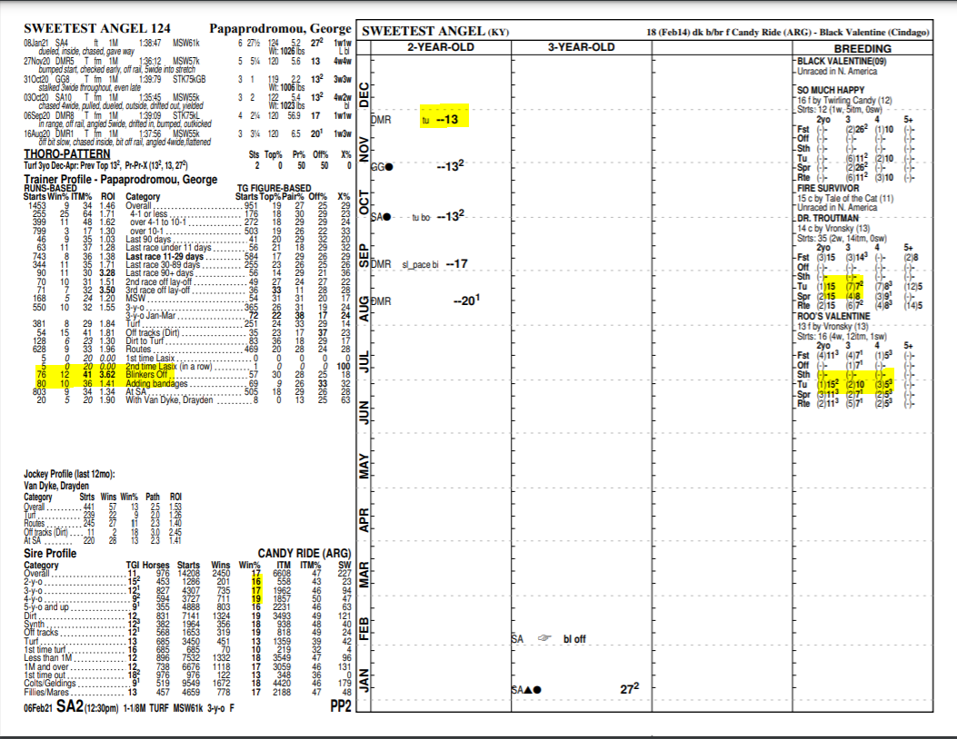

The blinkers coming off for a horse that is going to be the likely pace setter is also appealing to me. If she breaks well and gets to the lead, the shades off allows her to see and sense the competition coming sooner, and if competitve and game can kick it in. That’s the hope. The “94” TFUS Early pace figure is 13 points the fastest in this group. Looking back at the 2 races she was out clean in and sent to the lead, neither was she able to get an easy lead, causing tiring duels. The angle here today is lone loose speed, which at these long turf distances can be very dangerous if DVD can do it at comfortable fractions.
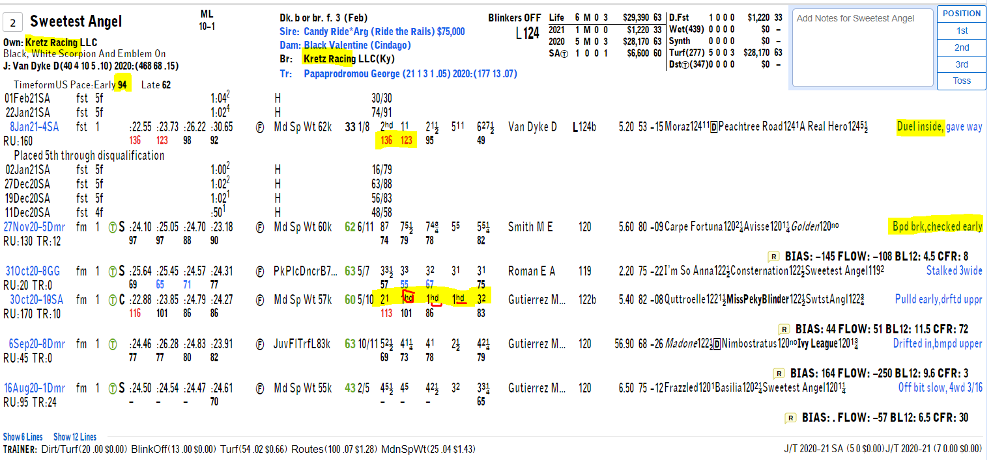
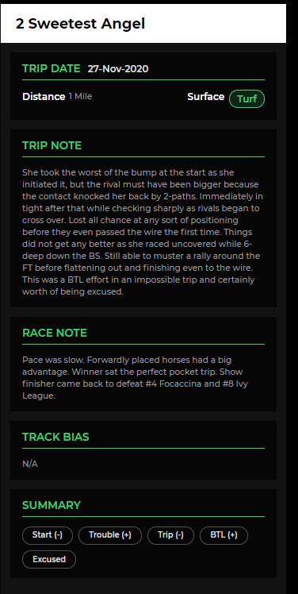
The trip note to the left here, by Trip Note Pros, tells the story of her last turf start from November. This impossible trip that resulted in a 5th place finish, combined with a failed dirt experiment next out certainly are driving factors in the price we get today, and in both cases, we find legitimate excuses that can be ignored.
Picking winners is important, but finding value in price is key to long term profits. If we see 10-1 here on Sweetest Angel, certainly worthwhile taking a shot on the win end and including in horizontals or exotics.

Race 3: A Case AGAINST #3, Moonlight D’Oro (1/1 ML)
Look, this one could very well be the goods, and if wins, would not be shocked, but this is all about taking shots against horses I see not worthy of the short price they will likely have. Assuming this one goes off as odds on favorite today, but there are a few tough fillies in here that will not make this a cake walk. Watch the last race of Honor America and her gameness in the lane against Donna Bella or the 11-length victory by #1 Moraz for Michael McCarthy in start number 2. Then we have Kalypso, an improving Baffert filly that romped in the Santa Ynez the stepping stone to this race today. Tough field, but let’s get to the other reasons why I am taking a shot against this favorite.
The last race was impressive, both the result and how she did it with flanked stalking trip and impressive final quarter in first route with a big gallop out. But, keep in mind, LRC is a very different track than SA, and often times you need to take the speed figs with a grain of salt. LRC has the longest stretch of the SoCal tracks, so the final quarter times are often faster as they have the opportunity to build up momentum in the long stretch, where SA and DMR the ¼ pole is on the turn. When I see blue coded pace fractions (highlighted below) at LRC the expectations are to be very fast in the final quarter, so this is not “special” and was a factor in the final time and speed figure. Also, the pace in this race today has speed to both her inside and outside, so Prat will have early decisions to make.
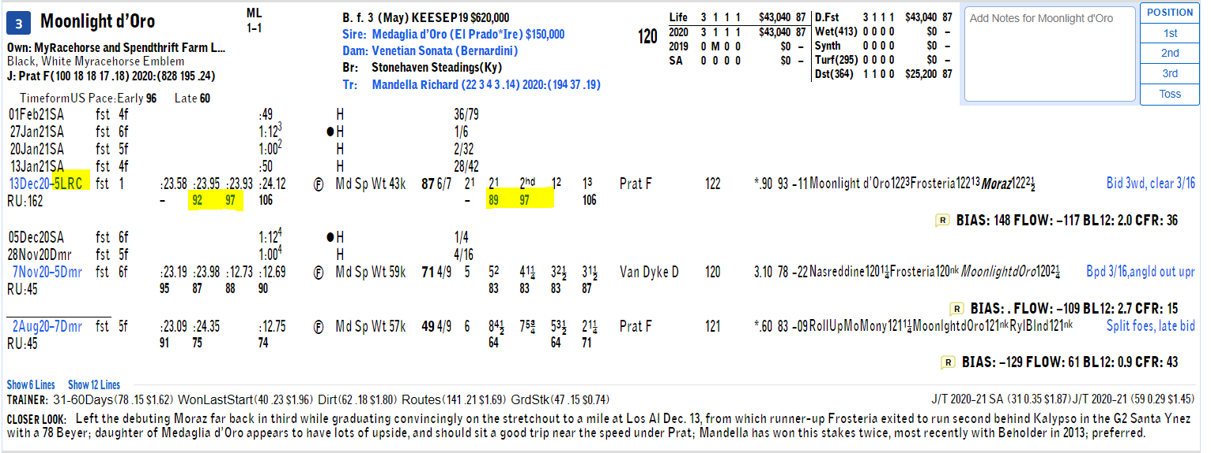
Below are the siblings out of Venetian Sonata. Two debut winners, then declining speed figures and a non-winner. This is a $650k yearling purchase, so the expectations are high, but there is nothing exciting here. The Dam was 0-3 on dirt, and also won debut only to not see the winners circle again in 8 other tries.
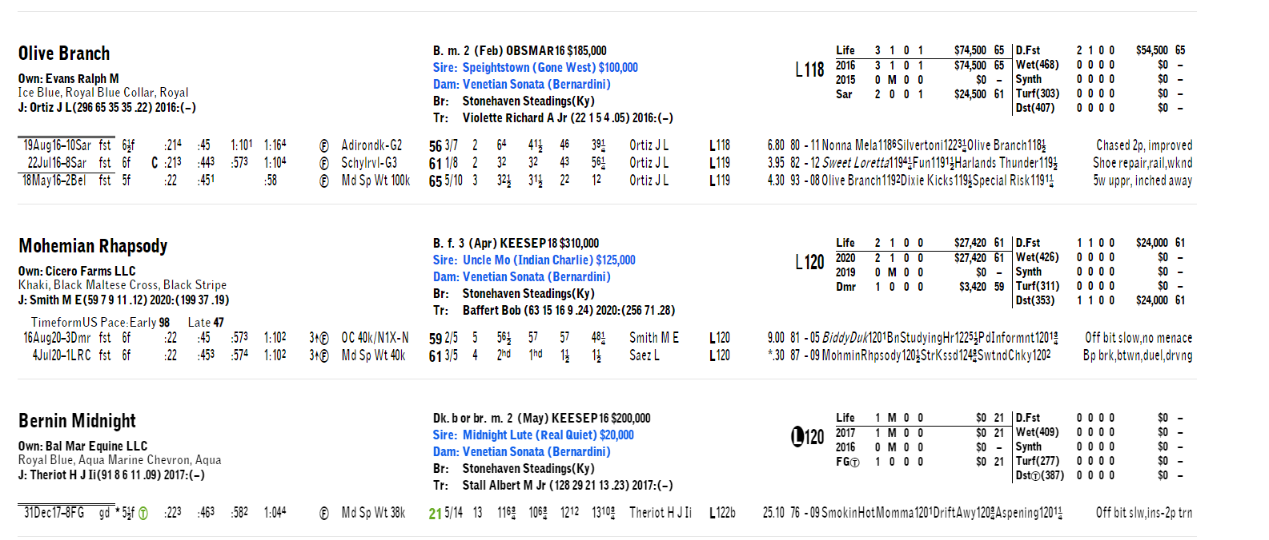
At anything around even money, there is enough evidence here that this one is likely to regress off the last big start and amongst this group, regression is unlikely to get it done.
Race 4: A Case FOR #6, Oscar Dominguez (7/2 ML)
It has been a long while since I bet this salty 8-year-old, but today is the day. Two big factors here that I believe lead to 7/2 being very good value. First, competition. There is no Arklow, United, Red King, or Zula Alpha (all Breeders Cup Caliber horses) entered in this race today. After going through the gauntlet, this group is a much better fir for Oscar. Second, is style and field size. Oscar flies from the back of the pack each race, and this style is dangerous to bet on as it takes overcoming traffic and losing too much ground to get into the winner’s circle. Today Umberto gets the outside post in a very small field of 6 (relative for turf racing), where he will take it easy and navigate him to the rail and work a ground saving trip. It also appears the pace could be strong upfront with the likes of Acclimate and Masteroffoxhounds entered, which bodes well for Oscar Dominguez’s running style.
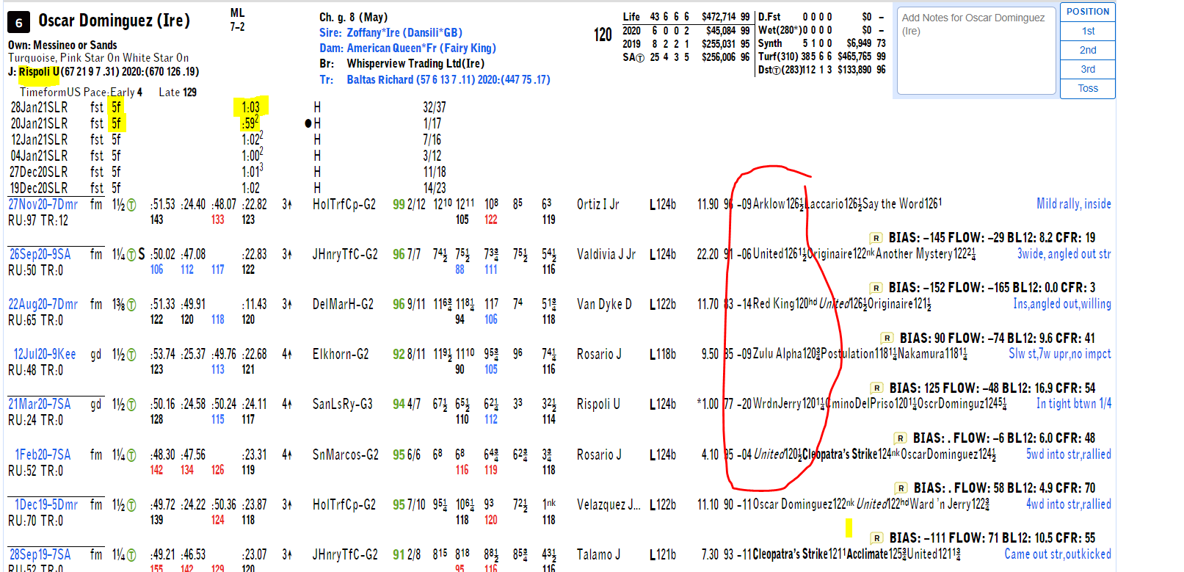
Next thing that jumps out are his consistent thorograph figures below. The “4’s” he earned could win this race here today, and are the top figures of this group over the last year. Sal Mundi is next best, with a “5” of late, and one that could absolutely win today, but will be a shorter price. 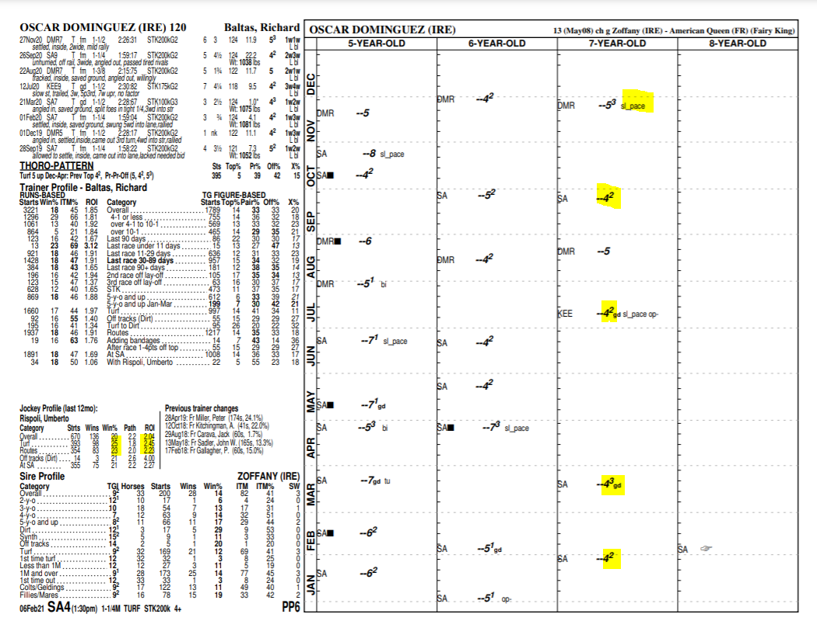

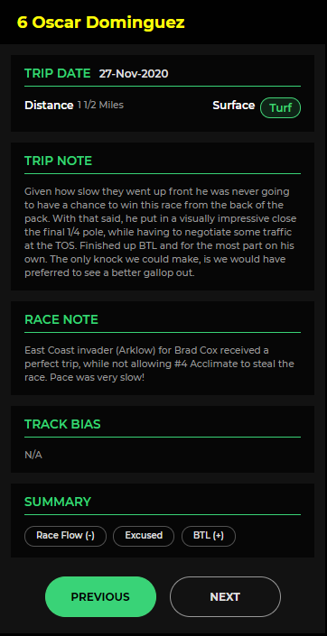
Trip note also gives a ”BTL” summary due to slow pace he ran into.
Then see below. I mean, it’s pretty obvious at this point that Umberto Rispoli is the best turf rider on the West Coast and he has been red hot of late. I like the pairing here with Oscar Dominguez, as NO ONE rolls the dice more and wins than Umberto when it comes to making bold moves off rail trips. He is a strong finisher and gets paired with a horse of the same quality.

3/1 or better is certainly a value play, for this morning line 4th choice.

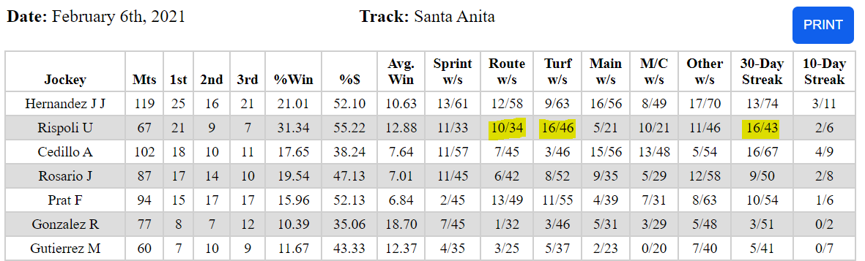

Wishing you all the best today. Feel free to DM me on Twitter @RMcCarthy1 anytime with questions or feedback.

Credits: @clockerandy with www.nationalturf.com; Thoro-graph data from https://www.thorograph.com/ ; http://www.tmracingdata.com and DRF Formulator at https://www.drf.com/formulator, Trip Note Pros https://www.tripnotepros.com/, RacingFlow http://racingflow.com/

