

“A Case for, A Case Against”
By: Ryan McCarthy (@RMcCarthy1)

Race 5: A Case AGAINST #6, Shadow Sphinx (5/2 ML)
There is no doubt Shadow Sphinx has enjoyed success on this track, finding the winners circle five times here at Santa Anita, including four of the last five tries. Today is asked to go his furthest distance yet. Notice regular rider, the red-hot Flavien Prat came off on the 1/23 ride due to him being in South Florida for The Pegasus. That led to Valdivia getting the mount, in a field with no Rispoli or Prat, not to mention a much softer field than todays competition, and he took advantage.
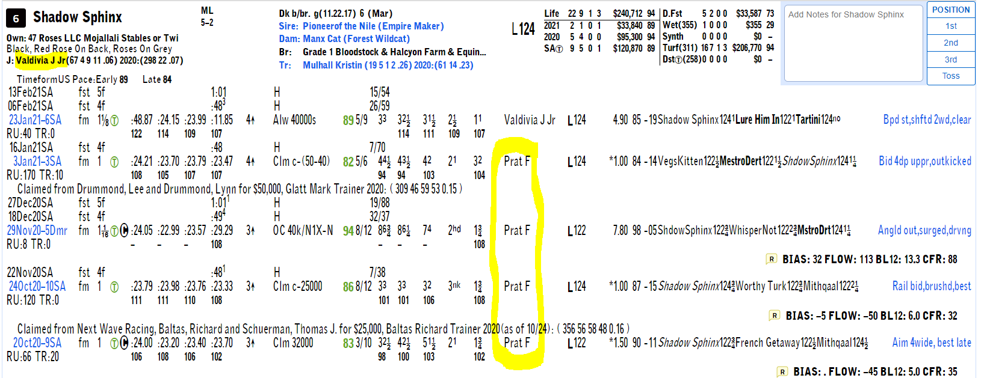
I am assuming Prat would have been welcomed back with open arms on this mount, but instead, chooses Ward and Jerry. Valdivia is far from solid on the turf, see below with his statistics over the past year, winning only 4% of 161 turf starts and 5% of 152 routes. Yikes. Then we look at the trip note captured by the team at Trip Note Pros. In winning the last race, it was done with a favorable trip, with a misleading line in the form on the early bump that had little to no effect.
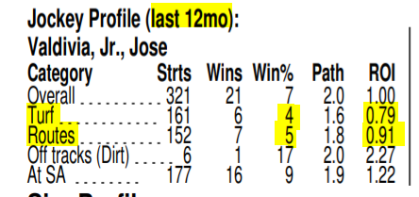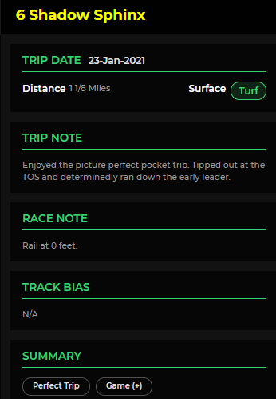
Now on the figure front. Valdivia’s win scored a 7 on Thorograph, regression from Prat’s rides, despite a perfect trip. 6 of these in here today have recent figures better than this figure. Valdivia would need to revert this one back to similar figures achieved when Prat was aboard, something I am not willing to bet on.
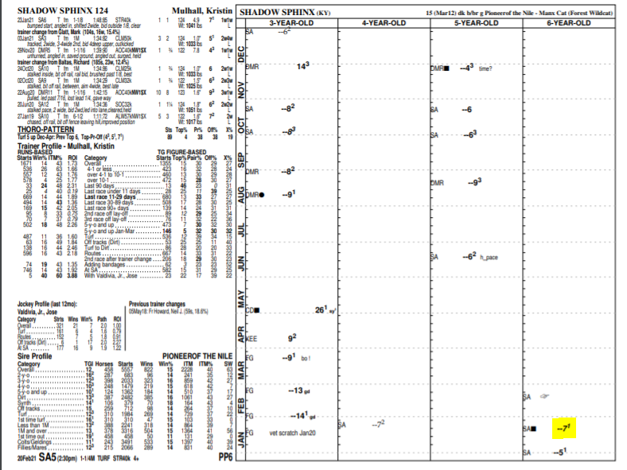
Race 7: A Case FOR #8 Charmaine’s Mia (3/1 ML)
Usually like to look for longer prices for these cases, but value is value, and if this one is 3/,1 I will be firing. Best top figure, top jock, super sharp recent work telling she’s on toes, and a favorable pace scenario. Below is Charmaine’s sheet, with a “3” figure last out, a fig no other horse in here has achieved to date. 2nd off the layoff and strong works, also pasted below, are telling of ability to match or improve from last figure, meaning others will need to really jump up to match Charmaine if she runs back.
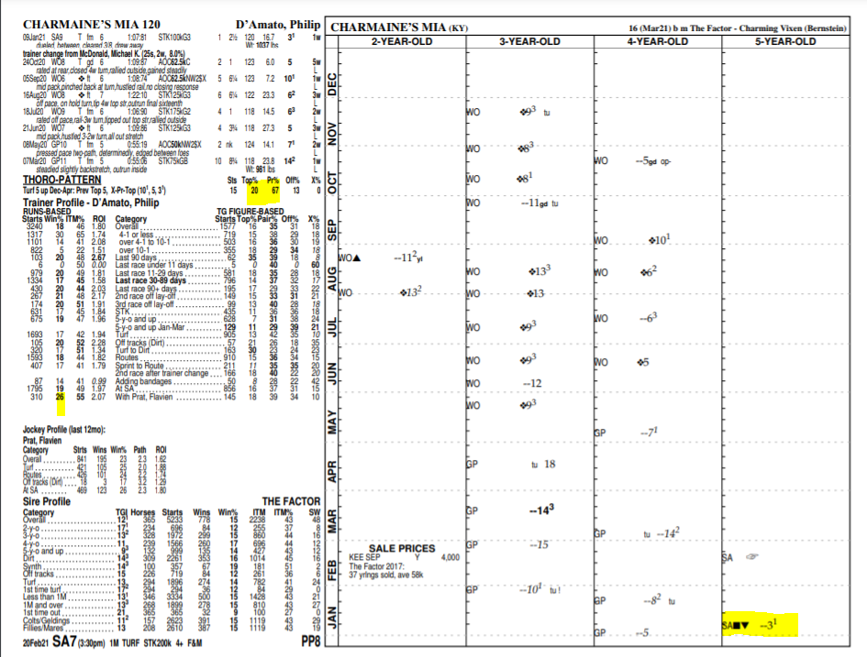
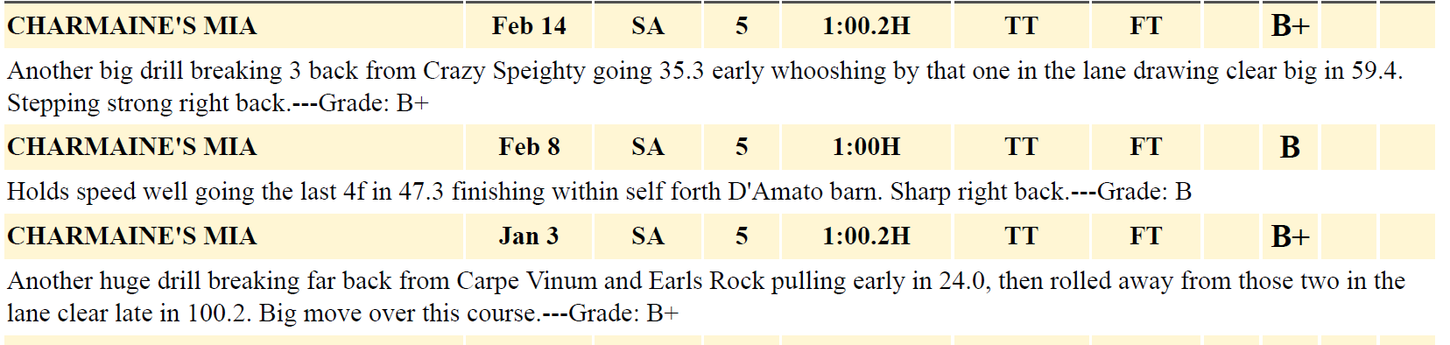
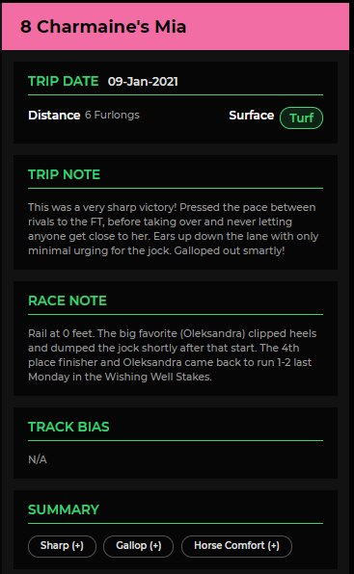
Trip note tells the story here, super sharp effort with more in the tank. Then look at the race note, two horses from last came back to run 1-2 in The Wishing Well Stakes, further justifying this effort.
TimeForm US Pace projector below shows what would be a favorable scenario with possible duel up front. Charmaine will be close, and although rails are only at 10 feet, the pace to be by the time they hit the top of the stretch is within 2 lengths, a likely scenario here today.
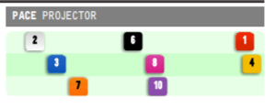

Race 8: A Case AGAINST #10 Simmer Down (2/1 ML)
Two weeks back Emily Ellingwood won her first race ad was my “A Case for” that day. Today, she is the ML favorite in this race from the 10 post on a maiden. This screams “vulnerable favorite” spot here. Last race was nearly 10-1 and was 6+ lengths beaten in 2nd. Since has had sharp works for this level. The third-place finisher from last race comes back here today, and was even money in last for Peter Miller. Now that horse gets Prat and Blinkers, both very positive changes for the Miller barn.
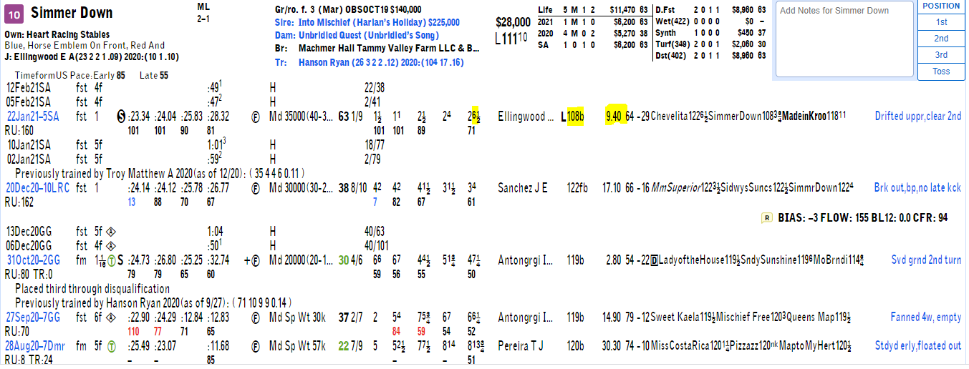
Looking at Time Form US Pace Projector, it shows potential loose speed with the #3. This is where I think the blinker on angle for the #4 comes into play where I would foresee that one much closer to the action. So that leaves Emily with decisions to make early. If she sends and does not clear, she gets caught wide in the first turn and loses ground. If she gets the lead, she better hopes to have much the best horse in the race as front end is not where one has wanted to be. If she lays off, she is going to need to navigate a trip to get to the rail, save ground and then get around traffic late. Lots of concerns for a short price and apprentice with 2 wins on her record.
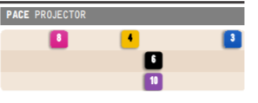
Last race has already produced 2 next out winners. So, this is a positive for the 10 here, but also a positive for the #4 Made in Karoo, who I feel will be tough today.
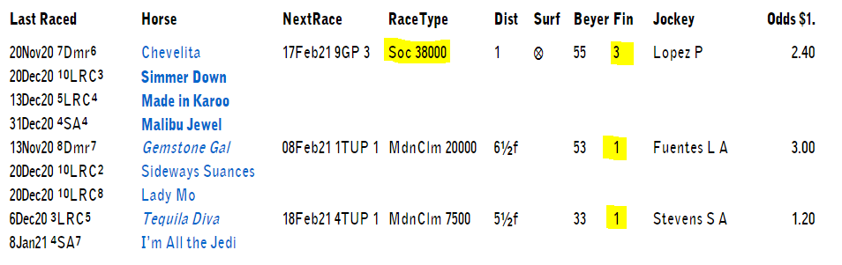
Made in Karoo a single for me today.

Race 9: A Case FOR #5 Golden Star Rock (30/1 ML)
Now time to have some fun with a 30/1 shot. Pedigree play but other angles to like here too. This $400k 2YO purchase ended up being gelded before hitting the track for the first-time last summer and started his career at Belterra and then Mountaineer for Wesley Ward. No doubt, these tracks were a factor in the 30/1 designation and the early move to geld is telling this one would not live up to the purchase tag. Was transferred to the Peter Miller barn in January and has been working at Pete’s home training track at San Luis Rey with five consecutive works. Has run with some early pace so far, a style that Miller can improve. I highlight the dam here as she has dropped some serious talent.
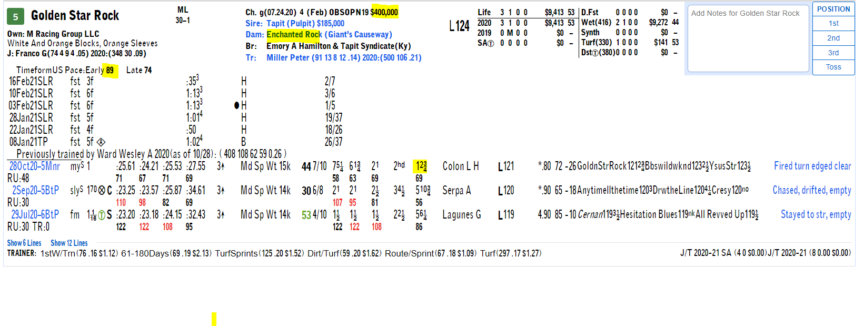
Using DRF Formulator, take a look at the half siblings of this horse, both out of Enchanted Rock. That’s right, 2 Kentucky Derby runners and graded stakes winners. On the sire side, we know Tapit’s can be head cases from time to time, and can take some time for the lightbulb to go off.
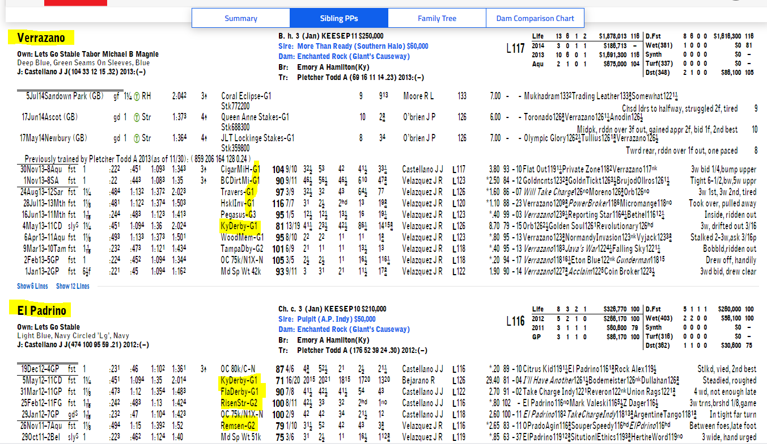
Pete’s speciality has always been turf sprints. This is a pedigree reach as out of 45 starts for Enchanted Rock’s babies, only 6 have been on turf (all routes) and no winners. But take note that Wesley Ward started this one on turf to begin career, so it is possible this one may just be light on his feet.
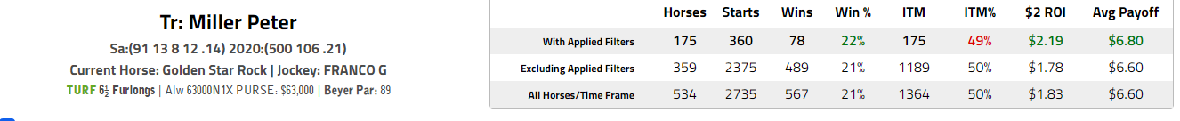
Plenty of red flags here, yes, but for the price and with this trainer, definitely worth a play at big odds and an include in horizontals/verticals.

Wishing you all the best today and good luck with your boxes and props for the Super Bowl tonight. Feel free to DM me on Twitter @RMcCarthy1 anytime with questions or feedback.
Credits: @clockerandy with www.nationalturf.com; Thoro-graph data from https://www.thorograph.com/ ; http://www.tmracingdata.com and DRF Formulator at https://www.drf.com/formulator, Trip Note Pros https://www.tripnotepros.com/, RacingFlow http://racingflow.com/, TimeFormUs www.timeformus.com

